NEWS ANNOUNCEMENT
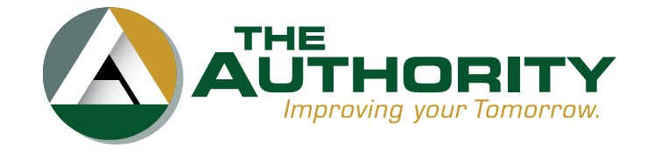
The Authority
745 Lebanon Road
Millville, New Jersey 08332
www.theauthoritynj.com 856-825-3700

The Authority Announces Reusable Bag Collection Program
MILLVILLE, NEW JERSEY. (February 23, 2024) – The Cumberland County Clean Communities Program is proud to announce its Reusable Bag Collection Program, presented by the Charlotte Brago Senior Center in partnership with Deerfield Township Clean Communities, and The Authority of Cumberland County, NJ.
As a result of the 2022 Single-Use Plastic Ban, many Cumberland County residents have gathered an overabundance of reusable bags, especially those from shop-from-home services. Instead of excess reusable bags becoming waste, the Cumberland County Clean Communities has launched a reusable bag collection program. The program collects new and gently used reuseable bags and has them professionally sanitized. The sanitized bags will be re-distributed and donated to local food banks in Cumberland County. Reusable bags must be free of any tags, stickers, and food contamination. Single-use plastic bags will not be accepted.
New and gently used reusable bags can be donated to two local drop-off locations. Drop-off locations are located at the Cumberland County Solid Waste Complex Guard Shack at 169 Jesse Bridge Road, Millville, NJ 08332, Monday through Friday 7:30am-3:30pm. Reusable bags can also be dropped at the Deerfield Township Charlotte Brago Senior Center at 736 Landis Avenue, Bridgeton, NJ 08302, Monday through Thursday 10:00am-3:00pm. The Authority will also be hosting drop-off events in conjunction with the Household Hazardous Waste and Document Shredding events on April 13, June 15, and September 14 at 169 Jesse Bridge Road, Millville, NJ 08332 from 8:00am-2:00pm.
“The Cumberland County Reusable Bag Collection Program will not only provide residents with an outlet to donate their excess reusable bags, but also helps residents give back to their own community,” said Samantha DeFrancisco, Cumberland County Recycling and Clean Communities Coordinator. “I am grateful for our partnership with Deerfield Township Clean Communities and the Charlotte Brago Senior Center and look forward to giving the bags a second life at our local food banks.”
“The Authority continues to seek out new and innovative solutions in the environmental industry. This program aligns with our forward-thinking mission, and we are proud to help the environment and those in need,” said Jason Scythes, Authority Board Member.
For more information, please contact Samantha DeFrancisco, Cumberland County Recycling and Clean Communities Coordinator, at (856) 825-3700 Ext.1270 or samdefrancisco@theauthoritynj.com.
In addition to its environmental related initiatives, The Authority is responsible for the development, financing and project management of projects and programs most vital to sustaining the economic and environmental future of Cumberland County and the state of New Jersey. The Authority works in tandem with the Cumberland County Board of Chosen County Commissioners to foster greater economic growth, business development and quality of life for all Cumberland County residents.

Contact: Samantha DeFrancisco
Cumberland County Recycling and Clean Communities Coordinator
The Authority
745 Lebanon Road
Millville, NJ 08332
856-825-3700x1270
samdefrancisco@theauthoritynj.com
